

Measurement & Improvement Initiative

The Aggregate Analysis Reporting Tool (AART) Settings and User Roles

Background and Context
Unless an immunization information system (IIS) says otherwise, it is generally assumed that an IIS connecting with M&I has a desire to broadly participate by being measured and sharing results. We believe IIS benefit from viewing and sharing results with peers across IIS and immunization programs, as well as with our Centers for Disease Control and Prevention (CDC) partners, to both recognize success and support improvement. To this end, AART defaults to inclusion in measurement and sharing, but provides control to admin users to set sharing settings as they choose.

Measurement and Sharing Settings
An IIS can choose to declare interest in being measured in specific content areas. An IIS can also select which groups to share results with (i.e., IIS/immunization programs, IIS vendors, CDC/National Institute of Standards and Technology [NIST], and electronic health record [EHR] vendors). During the registration process, AART users are identified as from an IIS or immunization program, an IIS vendor or technology partner, CDC/NIST, or an EHR vendor. This allows an IIS to choose which types of users can see its results. An IIS can also choose to share results in named (identified) or unnamed form. Unnamed means the results will be listed in the “My Peers” section but with a code in place of the IIS name. If an IIS chooses not to be measured, no testing will occur, and no results will be shared.
How to update Measurement & Sharing settings:
- Log in to AART as an admin user.
- Click on “Settings” in the left-hand menu.
- Click on the “Measurement & Sharing” tab to update permissions.

AART User Approvals
Admin users can approve their own AART users. This feature gives AART admin users the ability to log in to AART and approve those who request access to view their program or organization’s IIS reports.

How to approve AART users
Once a user registers on the AART homepage and selects the specific system they would like access to view, the admin user for that IIS or organization will receive an email instructing them to log in to AART to approve the user.
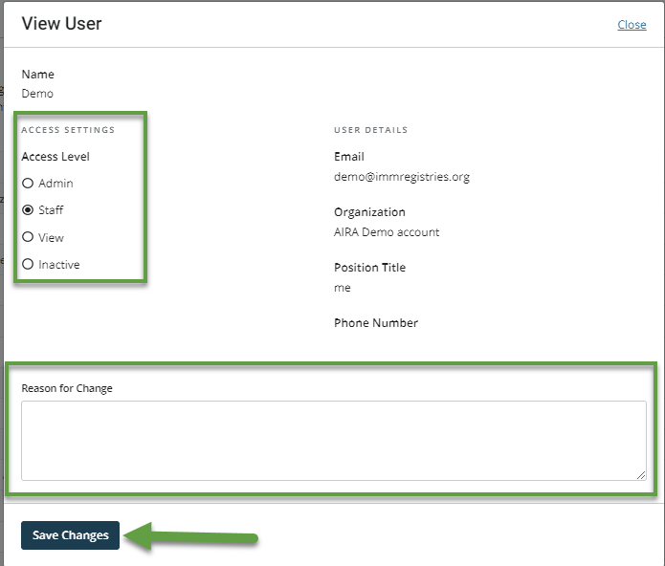
- Once logged in, navigate to “Settings” in the lower left-hand menu and select the “Users” tab. Admin users can see active users who have access to their IIS data, pending users, and authorized users who can be reviewed.
- Click “View” next to any user who needs review. The “View User” box will open, and the admin user can update the user access level. If deactivating a user, the admin user must type in a reason for the change before clicking “Save Changes.”
- If a user should not be approved, select the “Inactive” access level.
- Use the “Search” feature below the “Pending Users” section to search for existing AART users to give them access to their individual IIS data. Searching for existing users is useful when specific users from your IIS vendor or technology partner want access to your AART results and you want to grant access to select users rather than share your results with all IIS vendors or technology partners.
Reminder: The admin user access level can adjust settings and approve users. The staff user access level is typically used for IIS and immunization program staff, while the view user access level is typically used for IIS vendors or technology partners, EHR vendors, and CDC users.
For more information or questions on approving users, please email aart@immregistries.org.

Business Rules
To ensure transparency, AIRA created the following rules and table to document how AART settings function within the application.
As future content areas are rolled out, it is assumed users want to participate and be measured, but all past sharing indications of “No” will be carried forward. Once set, a setting will not change from quarter to quarter. For Validation, users will have 30 days to view their results and update their settings before information is shared in AART or elsewhere.

Defaults for future content areas of measurement (patient saturation, security, etc.)
 | Status in AART for Current Content Areas | Status in AART for Future Content Areas
Measure My IIS | Check box not selected | Yes
Measure My IIS | Check box selected | Yes
Sharing Settings* | No | No
Sharing Settings* | Yes/Yes Unnamed | Yes/Yes Unnamed
Notes: | A “No” in Assessment for Include My IIS in Measurement or a “No” in any Assessment sharing setting for a given content area would roll forward to a “No” in Validation for that content area.

Defaults for future stages of measurement (Testing and Discovery, Assessment, Validation)
 | Status in Testing and Discovery in AART | Status for Future Assessment Stages | Status for Future Validation Stages
Measure My IIS by Content Area | Check box not selected | No | No
Measure My IIS by Content Area | Check box selected | Yes | Yes
Sharing by Content Area* | No | No | Sharing settings are not applicable for Validation since Validation results are reported for all participating sites.
Sharing by Content Area* | Yes/Yes Unnamed | Yes/Yes Unnamed
*The sharing settings in AART are specific to each group an IIS chooses to share with (i.e., IIS/immunization programs, IIS vendors, CDC/NIST, and EHR vendors), and the status in AART will follow the business rules above for each group.

Reminder: AART settings can be changed by AART admin users at any time.

