

Extract Specification
CDC-Endorsed Data Elements

September 19, 2018

CDC-Endorsed Data Element Extract Specification

Introduction
This specification describes a common file format for CDC-Endorsed Core Data Elements which could be extracted from an IIS. The scope/quantity of the data extracted by the process (e.g. query) is beyond the scope of this document and shall be provided in a separate companion guidance document on a per project basis. The goal of this document is to define a reusable extract format.

Overview
Key steps (refer to Figure 1):
- Develop/implement process to extract specified data elements
- Execute extraction process (ex. DBMS queries)
- Store the extracted Patient data elements and Vaccine data elements into a separate ASCII text files (Tab separated values) with a unique IIS Patient ID used to associate data between them.

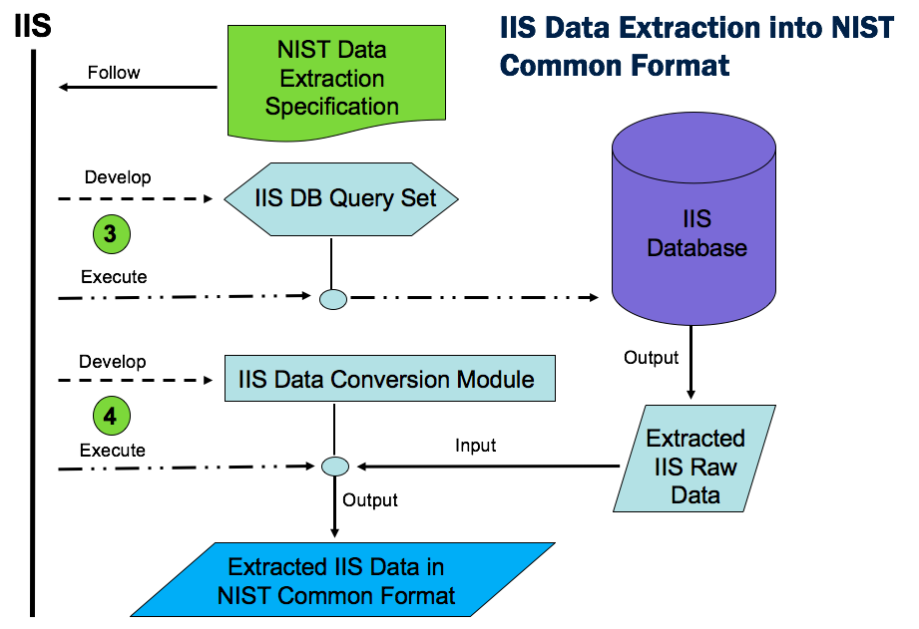
Figure 1: Extract process

Output Format for Extracted Data Elements
All data shall be output to the relevant Extract File as UTF-8 encoded text strings (see: http://wiki.hl7.org/index.php?title=Character_Set_used_in_v2_messages) without change from the local representation except for:

- Elements which represent Dates (e.g. Date of Birth) shall be stored using the date string format: YYYY-MM-DD (4-character year; 2-character month; 2-character day).

- Elements represented using a coding system (e.g. Product Type may use CVX codes, local codes, etc.) shall be stored according to the coding system prescribed in HL7 V2.5.1.

Patient and Vaccine Extract File Format
Extracted patient and vaccine-related data elements (see tables 1 & 2) shall be stored in two separate files, a Patient Extract File and a Vaccine Extract File. A Patient ID data element is used to link every patient record to its corresponding vaccine record(s). The structure of both files, referred to below simply as “Extract File,” are identical.

Each Extract File is a text file containing lines of tab separated values (TSV), where the first line consists of Data Element Name values from the tables below (Patient or Vaccine) - i.e. the column headings. Each subsequent line represents a logical “record,” consisting of tab separated values containing the extracted values corresponding to each “column.”

Note that it is possible for some extracted data elements themselves to contain one or more tab (ASCII 09) characters. In such instances, any tab characters appearing in data elements must be mapped to space (ASCII 32) characters in the Extract File.

Prior to data extraction, the IIS will be provided a companion document to define which patient and vaccine-related data elements are “in scope” and should be extracted versus those elements which should not be extracted (i.e. excluded). Additionally, prior to data extraction, the IIS shall determine which of the above “in scope” elements may or may not be extracted for any of the following reasons:
- the data element is never collected/stored by the IIS
- local policies prohibit release of the element, and any metadata associated with it (ex. presence, length, etc.)
- local policies only permit release of metadata only

The determination of which data elements shall or shall not be extracted must be consistent across all lines (i.e. records) of the Extract File. Thus, each data element shall either always be extracted (and therefore output to the Extract File), or never extracted, in which case a predefined string indicator (see Figure 2 below) shall be output to the Extract File in the respective column for that element.

Figure 2 provides a flow chart of how to determine what should be output to the Extract File for any given data element.

Step 1 is for the IIS to consult the companion document to see which elements are “in scope” for the extraction. Elements not in scope shall be represented by the special string “[[EXCLUDED]]” (quotes not included) in the Extract File.

Step 2 is for the IIS to determine which of the “in scope” data elements are actually extractable (i.e. are they in the IIS database?). Elements which cannot be extracted because they are not collected and/or not stored in the IIS database shall be represented by the special string “[[NOT_COLLECTED]]” (quotes not included) in the Extract File.

Step 3 is for the IIS to determine, based on their local policy, which of the remaining data elements (after steps 1 & 2 above) they are willing to extract. For example, the IIS may choose not to extract the element out of privacy concerns. In that case the element shall be represented by the special string “[[NOT_EXTRACTED]]” (quotes not included) in the Extract File.

Step 3 (Variation A): Some IIS, however, may determine that although they are not willing to extract the actual values of particular data elements, they are willing to indicate whether or not the element is or is not present in the IIS database (such information is essential to the quality analysis for measurement of data “completeness”). In such cases the special strings “[[VALUE_PRESENT]]” and “[[VALUE_NOT_PRESENT]]” (quotes not included) may represent the element in the Extract File.

Step 3 (Variation B): Similarly, some IIS may determine that although they are not willing to extract the actual values of a particular data element, they are willing to extract its length (e.g. it may be useful to the quality analysis to know the length of some data elements such as Patient Name). In such cases the special string “[[VALUE_LENGTH_IS {n}]]” (quotes not included) shall be used to represent the data element in the Extract File, where {n} is an integer representing the string length of element’s value in the IIS database. Note that data elements which contain empty/null (ex. note present) values in the database should result in {n} being set to 0.

Note that the above cases where data elements are not extracted is different from the cases where data elements are being extracted but contain empty/null (ex. not present) values in the IIS database. The latter shall result in <tab><tab> being output to the Extract File.

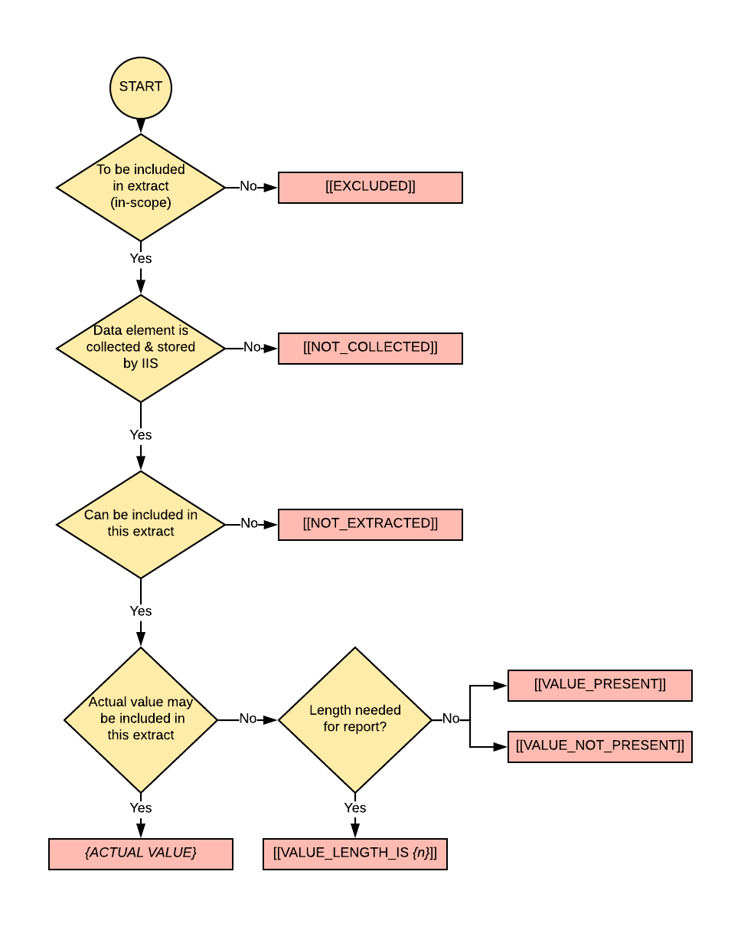
Figure 3: Extraction Decision Tree

Required Elements
Only data elements necessary to link records together (e.g. IIS Patient ID) or are used to report creation (e.g. Reporting Group) are required to always be populated. These are noted in bold. All other fields should be populated or left empty as indicated by the rules above and the directions for this particular export.

The linking elements are required to be unique between all associated files and for the purposes of this extract. However they are not required to represent the actual identifier, as used by the IIS. They may be generated for one-time use during the extraction. In other words, a record linked with IIS Patient Id “100” may or may not represent the same record in an export at a later date with the same IIS Patient Id “100”. The linking elements are only required to be unique and consistent across a single set of files extracted and submitted at the same time. Thus extractors have the option of further obfuscating the original patient id by not being required to export usable patient identifiers.

For all other fields, extractors must not skip records that are missing data that would normally be required by an IIS or ensure that empty values are populated with contrived information. This specification is designed to allow extractors to represent the data as it is, with the least amount of translation.

Patient Data Elements
The patient-related data elements to extract to the Patient Extract File are listed in the table below.

Note that all of the patient records in the Patient Extract File shall have at least one record in the Vaccine Extract File (see next section) unless the patient has no immunizations. Thus, if a patient record does not have a corresponding immunization record the analysis will assume this patient has received no immunizations.

Also note that patient information is assumed to be “consolidated” by the IIS prior to extraction, and thus a single set of the elements listed below are expected to be extracted for each Patient. Some IIS may store multiple representations of the same patient record or vaccination event, care should be taken to extract the single best representation (as the IIS can determine it) of the elements below. IIS should not extract all versions and variations of received and stored records.

Table 1: Patient Data Elements
Field # | Data Element Name | Format | Details | Value Set
1 | IIS Patient ID | String | Unique ID for this patient within this extract file. This may or may not be the actual IIS Patient ID within the IIS DB. A unique value is required within this extract file.
2 | Patient Name - First | String | The patient's first name.
3 | Patient Name – Middle | String | The patient’s middle name.
4 | Patient Name - Last | String | The patient's last name.
5 | Mother’s Maiden Name | String | The last name under which the mother was born (i.e., before marriage).
6 | Mother’s Name - First | String | The first name of the patient's mother.
7 | Mother’s Name - Middle | String | The middle name of the patient's mother.
8 | Mother’s Name - Last | String | The last name of the patient’s mother.
9 | Patient Date of Birth | YYYY-MM-DD | The patient’s date of birth.
10 | Patient Gender | String | The patient’s gender. | User Defined table 0001 (M, F, U)
11 | Patient Address - Street | String | The street component of the patient's address.
12 | Patient Address - City | String | The city component of the patient's address.
13 | Patient Address - State | String | The state component of the patient's address. | US Postal Service two-character Sate Codes
14 | Patient Address - Country | String | The country component of the patient's address. | HL70399
15 | Patient Address – Zip/postal | String | The zip code of the patient's address.
16 | Patient Race | String | The patient’s race. | User Defined Table 0005
17 | Patient Ethnicity | String | The ancestry of the patient. | User Defined Table 0189
18 | Patient telephone number | String | The patient’s phone number.
19 | Patient Email address | String | The patient’s email address.
20 | Patient Primary Language | String | The patient’s primary language | User-Defined Table 0296
21 | Patient Alias Name: First | String | The first name of a patient's alternate or also-known-as name.
22 | Patient Alias Name: Middle | String | The middle name of a patient's alternate or also-known-as name.
23 | Patient Alias Name: Last | String | The last name of a patient's alternate or also-known-as name.
24 | Responsible Person Name: First | String | The first name of the person responsible for the patient.
25 | Responsible Person Name: Middle, | String | The middle name of the person responsible for the patient.
26 | Responsible Person Name: Last | String | The last name of the person responsible for the patient.
27 | Responsible Person Name: Relationship to Patient | String | The actual personal relationship that the responsible person has to the patient. | User-Defined Table 0063
28 | Patient Multiple Birth Indicator | String | Whether the patient was part of a multiple birth (yes/no). | Y, N, or empty
29 | Patient Birth Order | String | When a patient was part of a multiple birth a number is defined in this element (e.g., 1, 2, 3).
30 | Patient Birth State | String | State of the birthing facility location. | US Postal Service two-character Sate Codes
31 | Patient status indicator—provider level | String | The current active/inactive status of the patient in relation to the provider organization. | User-defined table 0441
32 | Patient status—jurisdiction level | String | The patient/geographic jurisdiction status determined from address information when the patient's address within the jurisdiction is known. | User-Defined Table 0441
33 | Record Creation Date | YYYY-MM-DD | The date this patient was created in the IIS.
34 | Record Update Date | YYYY-MM-DD | The date this patient was last updated in the IIS.

Vaccine Data Elements

The vaccine-related data elements to extract to the Vaccine Extract File are listed in the table below.

Note that all immunization records in the Vaccine Extract File shall have a corresponding patient record in the Patient Extract File (see section above). If an immunization record does not have a corresponding patient record in the immunizations will be noted and discarded from analysis.

Table 2: Vaccination Data Elements
Field # | Data Element Name | Format | Details | Value Set
1 | IIS Patient ID | String | This is the IIS Patient ID from the Patient Extract File.
2 | IIS Vaccination Event ID | String | Unique ID for this vaccination event within this extract file. This may or may not be the actual IIS Vaccination Event ID within the IIS Database. A unique value is required within this extract file.
3 | Reporting Group | String | This field will be used to group immunization records for reporting purposes. This value is at the discretion of the IIS to assign a meaningful value depending upon how granular the IIS would prefer to see reports. More detail on this is found after this table.
4 | Sending Organization | String | The identifier of the organization that connects to the IIS and submits the record. This may or may not be the same as the Responsible Organization or Administered At Location.
5 | Responsible Organization | String | The identifier of the organization that originated and is accountable for the content of the record. May be referenced as IIS-AO ID. This may or may not be the same as the Sending or Administered at Location.
6 | Administered at Location | String | The facility name/identifier of the facility that administered the immunization.
7 | Vaccine Administering Provider | String | The name of the provider (person) administering the vaccination. Note that this "provider name" could include an actual name, or an ID
8 | Vaccine Type (CVX) | String | The vaccine type of the vaccination event. | CVX
9 | Vaccine Type (NDC) | String | The vaccine type of the vaccination event. | NDC
10 | Vaccine Administration Date | YYYY-MM-DD | The date the vaccination event occurred.
11 | Vaccine Manufacturer | String | The manufacturer of the vaccine that was administered. | MVX
12 | Vaccine Lot Number | String | The lot number of the vaccine administered.
13 | Vaccination Event Record Type | String | Indicates whether the vaccination event is based on a historical record or was given by the administered at location. | NIP001
14 | Vaccine Route of Administration | String | The route of administration | HL7-defined table 0162 or NCIT
15 | Vaccine Site of Administration | String | The anatomical site where the vaccine was given. | HL7-defined table 0163
16 | Vaccine Expiration Date | YYYY-MM-DD | The expiration date of the vaccine administered.
17 | Vaccine Dose Volume | String | The amount of vaccine administered (e.g., .5). Note all volumes will be assumed to be mL. If mL are not captured in the IIS, then this field should be set to [[NOT_COLLECTED]] for all records.
18 | Ordering Provider | String | The identifier of the provider (person) ordering the immunization. Note: this "provider name" could include an actual name, or an ID. May also be referenced as the prescriber ordering provider Identifier.
19 | Completion Status | String | Indicates if the vaccination event was successfully administered. | HL7-defined table 0322
20 | Dose Level Eligibility | String | The program that should pay for a given immunization, based on the characteristics of the patient and the type of vaccine administered. | User defined table 0064
21 | Vaccine Funding Source (Dose Level Public/Private Indicator) | String | The funding source of the vaccine administered. That is, was the vaccine administered purchased as publicly funded, privately funded, or with other jurisdiction specific funding. | PHVS_ImmunizationFundingSource_IIS (2.16.840.1.114222.4.11.3287) or locally defined codes
22 | VIS - Identifier | String | The VIS GDTI document code | VIS GDTI
23 | VIS - Publication Date | YYYY-MM-DD | The publication date of the Vaccine Information Statement.
24 | VIS – Given Date | YYYY-MM-DD | The date the VIS information was provided to the patient.
25 | Record Creation Date | YYYY-MM-DD | The date this vaccination event was created in the IIS.
26 | Record Update Date | YYYY-MM-DD | The date this vaccination event was last updated in the IIS.

Reporting Group can be used to stratify the data into like groupings. This field and expectations can be further defined in project specific extract specifications. Below are a few examples of how immunization might be grouped:
- Responsible Organization
- Pharmacy submitted vs. non-pharmacy submitted
- Private vs. Public providers
- EHR Vendor system

Each example grouping above could be used to detect different trends in the immunization data.

“tab” refers to the ASCII HT (Horizontal Tab) character, which has a decimal value of 09, and is the same character typically generated by pressing the ‘Tab’ key on most keyboards.

