IIS Onboarding Template: Onboarding Registration Form

About this template
Use this template to develop an Onboarding Registration form for provider organizations to indicate their desire to exchange data with your immunization information system (IIS). An Onboarding Registration form supports your program in collecting basic information from an organization that is interested in onboarding, including name, address, and number of associated facilities/sites. An Onboarding Registration also collects general information about the provider organization’s electronic health record/health information technology (EHR/health IT) system(s) that will be used to support data exchange. Offering an Onboarding Registration process helps your program know the number of organizations interested in data exchange with your IIS.
This template is part of a suite of templates designed to support jurisdictional onboarding, i.e., the process and activities related to establishing an electronic interface between an immunization provider’s EHR/health IT system and a jurisdiction’s IIS. Figure 1 provides a visual indicating the use of an Onboarding Registration form, as well as other key documents and tools, throughout the IIS onboarding process. Templates to support the development of the additional documents and tools noted in Figure 1 are also available.

Figure 1. Jurisdictional documents and tools used in the IIS onboarding process
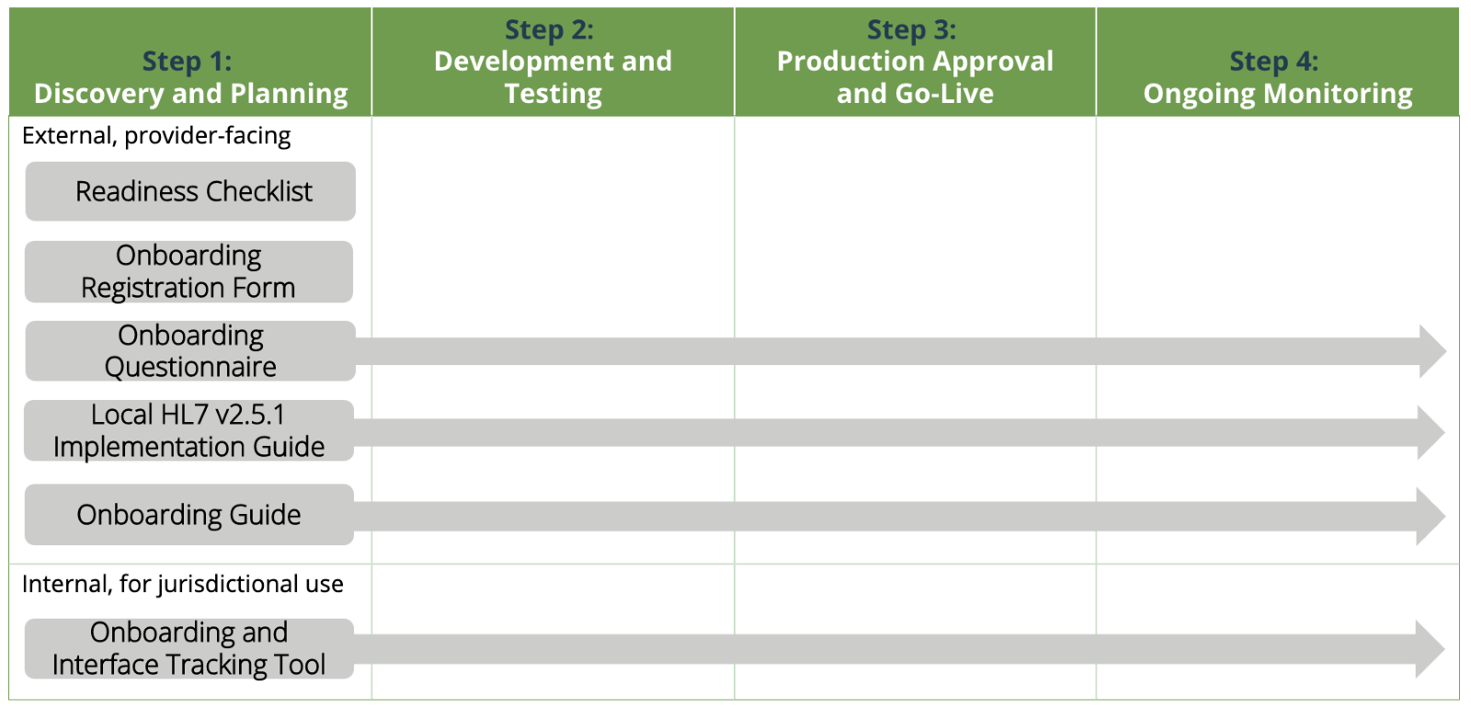
Development of this template was informed by guidance from AIRA’s Onboarding Consensus-Based Recommendations, as well as subject matter expert and IIS community input. Use this template to develop an Onboarding Registration or to help ensure your current Onboarding Registration form and process are consistent with other jurisdictions and best practices. By implementing practices and documentation consistent with other jurisdictions, you can more easily work with large national providers and their health IT representatives. This standardization also enhances the perception of IIS as a nationwide network of systems.

How to use this template
- Determine how you will collect Onboarding Registration information. Although presented as a Word-based template, implementing as a web-based form is the best practice to support efficient and automated data capture.
- Replace the yellow highlighted text with your jurisdictional information as indicated. Remove the yellow highlight formatting.
- Review the instructions for provider organizations and modify as needed.
- Review the questions and question response options. Add, modify, or delete as needed.
- Review the implementation considerations to address additional questions about operationalizing use of this registration form.
- Publish your final Onboarding Registration form online, along with your jurisdiction’s other onboarding and data exchange resources. Ensure cross-linking across these resources.

Implementation considerations
- It is a best practice to automate collection of this information through use of a web-based form. Consider what tools are available to you to support implementation (e.g., your IIS, Google forms, SurveyMonkey, REDCap, Smartsheet form, etc.). Consider how to make it easy for organizations to complete and easy for your program to access and use submitted information.
- If implemented as a web-based form, add field validation if possible.
- If implemented as a Word-based form, where should organizations submit the completed Registration form? Do you have an IIS help desk email to collect submissions? Who can access and monitor submissions to this inbox?
- Do you need to coordinate with other entities/program(s) to support electronic data exchange, e.g., a Health Information Exchange organization and/or other programs within your agency?
- Where will the information collected be stored? You will want to be able to sort, filter, and search the submitted information; compare this information to information in your IIS; and update IIS provider organization records as needed.
- Can you automate the transfer of information collected on this form into an Onboarding and Interface Tracking tool (e.g., create a ticket in an onboarding tracking tool for each new submission)?
- Who will be responsible for monitoring registration submissions, reviewing the information submitted, and following up with submitters as needed?
- Who will be responsible for cross-checking submitted information with information potentially already recorded in the IIS and updating IIS records as needed?
- Consider implementing an automated welcome message for provider organizations that complete and submit the requested information to acknowledge receipt of the information and initiate stakeholder engagement. Include next steps the provider organization should take to prepare for onboarding (e.g., reference your Readiness Checklist and readiness activities, such as completing the Onboarding Questionnaire).
- Consider whether it makes sense for your jurisdiction to combine the Onboarding Registration with the Onboarding Questionnaire. Although designed as separate forms to be completed in sequence, jurisdictions with fewer provider organizations may choose to implement them as one longer form. Jurisdictions with more provider organizations may want to keep them separate to have a better sense of the number of organizations that want to onboard before they submit detailed technical information via the Onboarding Questionnaire.
- Who is responsible for maintaining this form and updating as needed? How often should the form be reviewed for potential changes? Who should be involved in review of changes, and who needs to approve changes?
*******Delete the cover page and instructions before publishing to your website ********

Onboarding Registration Form
Complete this form to register your desire to onboard for data exchange with the [jurisdiction] immunization information system (IIS), [IIS name]. If your organization’s electronic health record (EHR) or health IT system is already connected to the IIS, you can use this form to indicate a change to your existing interface. This registration is an initial step in the onboarding process to establish a new interface connection or to test modification(s) to an existing interface connection between an EHR/health IT system and the IIS. [If needed: Submit completed forms to contact/email].
Once you submit this information, you will receive an email confirmation. Be sure you have completed the additional activities outlined in the [Readiness Checklist (link)] to prepare for onboarding with the IIS. If you have any questions, please contact the IIS team at [email/phone]. Thank you for your interest in data exchange with [IIS name].

Organizational onboarding contact
Provide contact information for the person responsible for oversight and coordination of the organization’s onboarding efforts. This person will be the main point of contact for the IIS during the onboarding process.
Name
Title/role
Email address
Phone number

Organization information
Provide information about your organization and any associated facilities.
Organization name
Organization address (street, city, state, ZIP)
Type of organization | Select the most applicable option:  - Commercial vaccination service provider  - Corrections/detention health services  - Health center – community (non-Federally Qualified Health Center/non-Rural Health Clinic)  - Health center – migrant or refugee  - Health center – occupational/employee health  - Health center – STD/HIV clinic  - Health center – student  - Home health care provider  - Hospital  - Indian Health Service  - Tribal health  - Medical practice – family medicine  - Medical practice – pediatrics  - Medical practice – internal medicine  - Medical practice – OB/GYN  - Medical practice – other specialty  - Pharmacy – chain  - Pharmacy – independent  - Public health provider – public health clinic  - Public health provider – Federally Qualified Health Center  - Public health provider – Rural Health Clinic  - Long-term care – nursing home, skilled nursing facility, federally certified  - Long-term care – nursing home, skilled nursing facility, non-federally certified  - Long-term care – assisted living  - Long-term care – intellectual or developmental disability  - Urgent care  - Other
If other: Indicate type.
Is this organization currently enrolled in the IIS? | Select one  - Yes  - No  - Unknown
If yes: Indicate organizational IIS identifier, if known.
Total number of facilities (distinct physical locations/sites) associated with the organization
Are there any mergers or acquisitions planned that would change the number of facilities associated with the organization? | Select one  - Yes  - No
If yes: Indicate plans and timeline.
Does your organization administer immunizations? | Select one  - Yes  - No
If yes: Does your organization administer publicly purchased vaccine (e.g., Vaccines for Children (VFC) vaccine)? | Select one  - Yes  - No  - Unknown

Registration information
Provide information about the reason for the registration and technical onboarding needs.
Reason for registration | Select one  - Establish a new interface  - Change to an existing interface
If change to an existing interface: Indicate change(s). | Select all that apply  - Change in transport  - Change in message format  - Transition to a different EHR/health IT system  - Addition/removal of facility/facilities  - Add query to a submission-only interface  - Other (describe)
Indicate desired transport. SOAP Web Services is preferred. | Select one  - SOAP Web Services, CDC WSDL  - [List other transport option(s) available, if applicable.]
If other than SOAP Web Services, CDC WSDL, indicate reason.
Indicate desired message format. HL7 2.5.1 is preferred. | Select one  - HL7 2.5.1  - [List other format(s) accepted, if applicable.]
If other than HL7 2.5.1, indicate reason.
Indicate desired interface type. Submission with query is preferred. | Select one  - Submission with query: Allows for the reporting of data from EHR/health IT system to IIS and for clinicians to access patient immunization information from the IIS while working within the EHR/health IT system.  - Submission only: Allows for reporting of data from EHR/health IT system to IIS.  - Query only: Allows for clinicians to access patient immunization information from the IIS while working within the EHR/health IT system.
If other than submission with query, indicate reason.
Provide additional comments as needed regarding registration.

Electronic health record/health IT system information
Provide information about your organization’s EHR/health IT system(s) used in data exchange with the IIS. Note: If more than one interface connection is needed between the provider organization and the IIS, each will be treated as a distinct onboarding project.
EHR/health IT system vendor/developer
Are all facilities/sites within the organization using the same EHR/health IT system? | Select one  - Yes  - No  - Unknown
If no or unknown: Are additional interface connections needed with other EHRs and/or health IT systems? | Select one  - Yes  - No  - Unknown
Provide additional comments as needed regarding EHR/health IT system(s).

